

Software Engineering Department
Braude College of Engineering
Capstone Project – Phase A (61998)
Pedagogical Training

A Voice-Based Virtual Classroom for Teacher Training
CODE: 26-2-D-14
By:
Dganit Vainer
dganit.vainer@e.braude.ac.il
Harel Aronovich
harel.aronovich@e.braude.ac.il

Advisor:
Dr. Natali Levi-Soskin
natalyl@braude.ac.il

Link to GitHub:
https://github.com/dganitvainer/Classroom_Simulation

Abstract
Classroom management is the most common source of stress and attrition for early-career teachers, and the gap between theoretical preparation and the demands of a real classroom is well documented. Teacher-training institutions still rely largely on theoretical coursework, brief professional workshops, and infrequent, delayed mentor observations to prepare educators for these behavioral challenges. The Pedagogical Training project addresses this gap with an interactive, Hebrew-language virtual classroom in which teachers practice responding to behavioral disruption and receive immediate, personalized feedback on the pedagogical intent, tone, and timing of their responses.
This Phase A book builds on a working proof-of-concept that scored 85.9 on the System Usability Scale, in which a single centralized LLM call per timed cycle chose and voiced all student behavior at once, with no per-student state or memory. The present work redesigns this core around a separation principle: all classroom dynamics - which student acts, how each student’s internal state evolves, and what each student remembers - are governed by deterministic, auditable code, while language models are confined to two narrow roles: classifying the teacher’s intent, and generating in-character Hebrew speech. The workflow combines a Classifier (an LLM-based intent classifier) with concurrent, profile-driven student agents whose candidate reactions are ranked and selected by a deterministic Arbiter.
An evaluative layer assesses the teacher: an Evaluator scores each spoken response in real time on timing, tone, and pedagogy, an end-of-session Summarizer aggregates these into strengths and areas to improve, and a post-simulation Mentor - the system’s only AI tool-using agent - answers open-ended questions about the teacher’s own session in a ReAct loop. The class is teacher-configurable (size, student profiles, lesson topic), so one system supports a wide range of scenarios without code changes. This document presents the engineering process, system architecture, verification plan, and constraints under which the system is being built.

Table of Contents
Abstract 2
1. Introduction 4
2. Literature Review 5
2.1 Existing Approaches to Classroom-Management Training 5
2.2 The Gap and the Proposed Response 6
3. Engineering Process 7
3.1 Initial Phase: Identifying the Problem and Defining the Goal 7
3.2 Research: Educational and Technical Basics for Simulation 7
3.3 The Selected Design 9
3.3.1 The Classifier 9
3.3.2 Student Profiles and States 10
3.3.3 The Arbiter 11
3.4 The Evaluator 12
3.5 The Mentor 13
4. Product 13
4.1 Key Project Requirements (Functional & Non-Functional) 14
4.2 System Architecture 16
4.2.1 The Three Layers and the Database 16
4.3 Use Case Diagram 17
4.4 Activity Diagram - Lesson Flow 18
5. Challenges and Constraints 19
6. Expected Achievements 19
7. Verification and KPIs 20
8. AI Tools and Prompts 22
9. References 23
10. Appendices 25

1. Introduction
Classroom management remains the most demanding part of early-career teaching. New teachers face persistent low-level disruption alongside moments of open defiance, and the cumulative effect erodes instructional time and teacher self-efficacy. The link between classroom-management difficulty, professional stress, and attrition is well documented: international and U.S. estimates put first-year teacher exit rates near 30 percent and five-year exit rates near 50 percent [6][8][9]. The cost is borne three times - by the teachers who leave, by the students in unstable classrooms, and by the institutions paying to recruit replacements.
Pre-service training is heavily theoretical, with a small number of supervised observation hours rarely exposing candidates to the unpredictable, real-time behavioral situations they face on day one [2][4]. Mentor observations and induction-year seminars partially fill the gap but are infrequent, often delayed, and can themselves heighten the anxiety they are meant to relieve. Many new teachers therefore learn classroom management by trial and error in the live classroom, at significant cost to themselves and their students.
This gap is echoed by practitioners in the field: in an interview conducted for this project, an assistant principal with direct experience mentoring new teachers and guiding student-teachers through their classroom practicum described observing a live classroom as something new teachers "truly value," and stressed that this kind of exposure is needed "even during their academic studies," not only once they enter the profession (see Appendix 1).
Simulation-based training is one of the more promising responses. Mixed-reality systems such as TLE TeachLivE produce measurable improvements in targeted teaching behaviors after short, focused sessions [7]. Software platforms such as SimSchool support repeated, low-stakes practice without mentor-led observation. LLM-driven systems like SimClass [13] show that large language models can play classroom roles convincingly enough to support meaningful interaction. None of these tools, however, combines what an Israeli teacher-training program needs at once: native Hebrew, teacher-controlled class composition, real-time spoken interaction, and a cost profile that allows curricular-scale use rather than per-session specialist engagement.
This project addresses that combination. A previous effort produced a working proof-of-concept for the Hebrew, real-time, voice-driven simulation idea, scoring 85.9 on the System Usability Scale. The current Phase A is not a rebuild but a redesign of the decision-making core: rather than a single LLM orchestrating an entire class through one monolithic prompt, the system decomposes the classroom into individual student agents - each with its own behavior profile and internal state, and access to a shared episodic memory scoped per student - while a deterministic coordinating layer schedules interactions and a specialized evaluative layer assesses the teacher's response. The class itself is teacher-configurable: size, student composition, and behavioral profile mix are set before the session, so the same system supports a range of elementary-school classroom configurations without code changes.
The system serves three audiences - pre-service teachers practicing in a low-stakes environment, teacher educators integrating the tool into existing courses, and teacher-training institutions evaluating cost-per-trainee and curricular fit.

2. Literature Review

2.1 Existing Approaches to Classroom-Management Training
Theoretical coursework, professional development, and mentorship. The conventional pathway combines coursework, periodic workshops, and mentor observations during induction. Coursework provides a research-based foundation but rarely exposes candidates to severe or sustained disruption [4]. Mentor observations are valuable for contextual feedback but are infrequent, often delayed, and can themselves heighten the stress of the observed teacher [2]. This category lacks the volume of repeated, real-time practice needed to build automatic behavioral judgement.
Mixed-reality classroom simulators. The most established system is TLE TeachLivE, developed at the University of Central Florida and later commercialized as Mursion [7]. Student avatars are operated by a trained “interactor” who responds to the trainee in real time, and evaluations report measurable improvement after as few as four ten-minute sessions [12]. The pedagogical case is well supported, but every session requires a trained specialist, and the language/scenario library is not by default adapted to Hebrew or the Israeli classroom.
Software platforms with scripted student behavior. SimSchool configures a class from pre-defined student profiles and gives end-of-session performance feedback [11][12], enabling repeated practice without specialist staffing - but its focus is differentiated instruction rather than behavior management, and its responses are scripted rather than generative, constraining moment-to-moment realism [12].
LLM-empowered classroom simulations. Zhang et al. [13] introduce SimClass, a multi-agent classroom simulation in which LLM-driven student agents and a teacher agent interact in a structured pedagogical workflow, showing that multi-agent collaboration produces richer classroom dynamics than a single-prompt approach - but SimClass is designed for student learning, not teacher training. Adjacent work [10] explores LLM-driven student agents combined with 3D/VR classroom scenes for pre-service teacher training. Published systems in this category are predominantly research demonstrations: mostly in English, mostly not teacher-configurable for repeated curricular use, and evaluated as one-off experiments.

2.2 The Gap and the Proposed Response
Each existing approach contributes one component of what an effective tool requires, but no approach combines all of them: mentorship provides context but not repetition; mixed-reality provides presence but not scale; scripted platforms provide scale but not behavioral richness; LLM-driven research demonstrations provide richness but are not packaged as reliable, configurable products at the languages and cost profiles teacher-training programs require.
A previous Phase A/B effort at this institution validated the pedagogical benefit of such an environment [1], but relied on generalized student behavior and a single-prompt monolithic loop. The present project bridges this execution gap with a redesigned engineering blueprint centered on individually modeled student profiles and a Classifier-plus-Arbitration workflow, in which deterministic dispatching logic - not a second LLM call - governs turn-taking and student selection. To ensure pedagogical validity for local educators, the student profiles are calibrated to reflect the cultural dynamics of Israeli elementary schools, where interactions are informal, direct, and frequently challenge traditional authority [4]; these profiles were co-designed with active Israeli elementary teachers who described their actual classrooms, including personality archetypes, peer relationships, and typical friction.
Beyond behavioral fidelity, the response is architectural: real-time classroom decisions are handled by fast, deterministic code, while LLM calls are reserved for the two tasks that genuinely require language understanding - classifying teacher intent and generating in-character student speech. This split, detailed in Chapter 3, is what keeps end-to-end response latency low and stable regardless of class size, without sacrificing the behavioral richness that motivated the LLM-driven category above.
3. Engineering Process

3.1 Initial Phase: Identifying the Problem and Defining the Goal
The project aims to provide configurable Hebrew classroom practice with individually differentiated student behavior and constructive, personalized feedback. Initial requirements emphasized real-time responsiveness, pedagogical grounding, support for a full class, affordable operation, age-appropriate dialogue, and teacher-controlled lesson settings. These priorities motivated a hybrid design: deterministic code will manage student state and response selection, while selected LLM calls will interpret teacher intent, generate dialogue, and support feedback. Section 3.2 compares the alternatives; Section 4.1 specifies the requirements.

3.2 Research: Educational and Technical Basics for Simulation

Prototyping and Workflow Selection
The existing proof-of-concept [1] chooses which student responds by sending the whole lesson so far, the full roster, and every student's profile to one LLM call, every single turn. That call had to handle routing, selection, and generation together, so as the lesson went on and context piled up, it got slower, the opposite of what a live simulation needs.
The prototype's goal was simple: find a way to pick who responds that holds up on three things tied to Section 4.1: decision transparency (can we see why a student was picked, or is it a black box?), response speed (fast enough to feel like a real conversation?), and token efficiency (how much it costs per turn, and does that scale with class size?). A small prototype tested a few workflows against these three before landing on the Classifier and Arbitration design below.
 | Alternative 1: Orchestrator Workers | Alternative 2: Parallelization + LLM Aggregator | Alternative 3: Autonomous Per-Student Agents | Selected Design: Classifier and Arbiter
Selection mechanism | One large orchestrator LLM call reasons over full context + every profile, decides candidates up front | Every student runs independently in parallel and a separate aggregator LLM call judges outputs and picks who speaks | Every student is its own autonomous agent, independently deciding whether to react - no central selection | A narrow classifier LLM call classifies the teacher's intent (e.g. a question, a reprimand, praise) only; a deterministic step then selects candidates using live student metrics.
Decision transparency | Poor - selection buried inside one LLM call, no inspectable rule, not guaranteed repeatable | Poor - final pick is an LLM judgment, no inspectable rule | Worst - no central point where "who responds" can be inspected at all | High - selection and arbitration are deterministic code, same input → same output, unit-testable
Response speed | Poor - orchestrator call regularly exceeded 6s | Better (concurrent per-student calls), but aggregator call adds more latency on top | Poor - when several agents decide to respond at the same time, an extra step is needed to decide which one actually speaks - adding time on top of the parallel run itself. | High - ~3s or less, only the narrow classifier and actual candidates run on the critical path
Token efficiency | Poor - pays for full roster + lesson history every turn regardless of outcome | Worse than the adopted design - every student runs a full call every turn, most output discarded, cost scales with class size | Worst of the three - every student runs an LLM call on every turn regardless of relevance, with no filtering step at all | High - classifier output stays small regardless of class size, Actor LLM calls run only for flagged candidates
Reason ruled out / adopted | Ruled out mainly for speed, reinforced by poor transparency and efficiency | Ruled out mainly for wasting tokens at scale, reinforced by poor transparency | Ruled out - no coordination, worst on all three axes | Adopted - high on all three axes

3.3 The Selected design

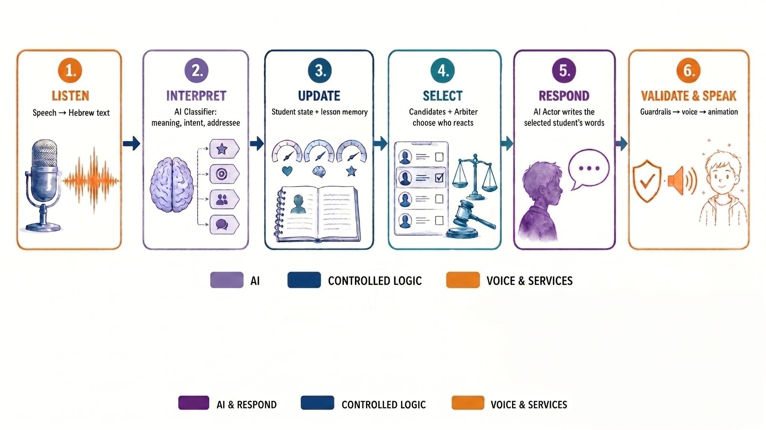
Figure 1: The live turn pipeline - from teacher speech to student response
3.3.1 The Classifier
The Classifier is an LLM call running on every teacher utterance, restricted to a single responsibility: classifying intent and routing. It never produces a student utterance - that remains the Actor agents' job. Its output is not sent to every student as a separate LLM call; instead, it is a single, small JSON object describing the teacher's classified intent (e.g. reprimand, open question, praise) and its target (a specific student, a group, or the whole class). A deterministic step then reads that intent and target, together with each student's live metrics and profile, to decide which student(s), if any, are plausible responders. Only this filtered set of students, never the full roster, goes on to trigger parallel Actor calls.
3.3.2 students profile and states
Origin of the nine profile - The system models nine student behavioral profiles:
hyperactive, talkative/social, defiant, in conflict with peers, sarcastic, sensitive, withdrawn, attentive, and neutral - inherited from the proof-of-concept team’s research with a pedagogical expert [1].

Profile Traits and Live States - Each profile will carry a fixed set of traits: how that kind of student will tend to speak, what will tend to provoke or calm them, and the register of behavior that will stay in character across the whole session. On top of that fixed layer will sit a live state, a small set of numeric metrics (energy, attention, engagement, mood) that will shift turn by turn in response to what the teacher does. The profile will define who a student is, but the state will define how they're doing right now.
Deterministic, not LLM-driven - These state metrics will not be estimated or narrated by a language model. They will move by explicit rule: a given teacher action will change a given metric by a defined amount, and which metric moves, and by how much, will depend on the student's profile. The same teacher action will not move every student's state the same way, an energetic profile and a withdrawn profile will respond differently to the same reprimand or the same praise, because the rules will be keyed to profile class, not applied uniformly.
We chose to update these metrics deterministically because empirical work directly comparing LLM-based decision policies to deterministic finite-state-machine baselines in agent-based simulation found that "LLM-based selectors can approximate the FSM policy in some cases, but they do not preserve it consistently," and that "prompt design alone was not sufficient to preserve the FSM policy... it did not define a stable decision policy across models" - the same prompt moved different models in opposite directions relative to the intended policy [3]. Using an LLM to update the metrics would risk introducing exactly this kind of inconsistency into every update, undermining the reliability of the system as a whole.

Student Disruption and Reaction Mechanism
Student behavior in the virtual classroom is dynamically generated by an AI model rather than being pre-scripted. However, the triggering mechanisms for behavior are divided into two distinct paths:
Spontaneous Disruptions - Spontaneous classroom events (e.g., a student suddenly blurting out, getting distracted, or throwing a tantrum) are driven by a continuous background loop. This path is governed by a strict threshold gate:
- The Trigger: The system continuously tracks each student's internal emotional metrics (such as energy, attention, and frustration) based on elapsed time and their specific psychological profile. Only when a student's metrics cross a predefined critical threshold does the system queue a candidate for a spontaneous disruption.
- The Role of Metrics: In this path, the internal metrics act primarily as a triggering gate. If the student is calm, no disruption is queued. Once triggered, the emotion vector is passed to the AI Actor model’s prompt to ensure the disruption matches the student's persona (e.g., a hyperactive student might yell, while a withdrawn student might put their head on the desk).
Reactions to the Teacher - Unlike background events, reactions are directly provoked by the user. When the teacher speaks, the system classifies the pedagogical intent (e.g., praising, reprimanding, or asking an open question) and processes it immediately.
- The Trigger: The teacher's move itself acts as the absolute trigger. The system intercepts the teacher's action and immediately shifts the target students' internal metrics - for example, a harsh reprimand will instantly spike a sensitive student's frustration.
- The Role of Metrics: In this path, the metrics do not act as a gate, but rather as an emotional context vector. The combination of the teacher's action and the newly shifted metrics is fed into the AI model, ensuring the generated response is a psychologically accurate reaction to the teacher's specific phrasing and tone.

3.3.3 The Arbiter
Both the spontaneous and the reactive paths ultimately converge at a central decision-making component known as the Arbiter. The Arbiter functions as a traffic controller for the classroom. Since multiple students might want to speak at the exact same time - whether because the teacher asked a group question, or because one student is reacting while another is simultaneously attempting a spontaneous disruption - the Arbiter evaluates all queued candidates based on priority rules, recent activity, and classroom context. It selects which single student gets the conversational floor, ensuring the classroom interaction remains realistic and does not descend into chaotic, overlapping voices. Once the selected student finishes speaking, their internal metrics shift once more to reflect the emotional consequence of their action, completing the behavioral loop.

3.4 The Evaluator
The Evaluator is responsible for the teacher's real-time learning and feedback. It is a single LLM call that scores the teacher's words and the situation against three criteria, and returns short Hebrew feedback addressed directly to the teacher.
Evaluator Inputs - The Evaluator will receive the teacher’s transcript, classified intent, the addressed student’s behavioral profile, and response-timing data. Intent will determine the relevant assessment criteria, while the student profile will provide context for interpreting the teacher’s wording. Timing will be considered only when applicable to the teaching move.

Scoring Mechanism: Three Axes of Evaluation - The Evaluator will return a brief feedback message alongside three core metrics, each scored on a 0-10 scale:
- Timing: Evaluates whether the teacher responded at the optimal moment. This measures factors such as intervening before a minor disruption escalates into chaos, or providing a shy student with adequate "wait time" to process a thought rather than interrupting them.
- Tone: A critical design point is that the Evaluator does not process audio, meaning it cannot detect vocal pitch, volume, or inflection. "Tone" is judged entirely on semantics and word choice. Utterances receive low scores for linguistically aggressive phrasing and high scores for delivering the same underlying request in a respectful and dignified manner.
- Pedagogy: Assesses whether the teacher utilized an effective instructional strategy. For instance, when a student provides an incorrect answer, the system evaluates whether the teacher simply shut them down with a negative response or effectively used guiding questions to help the student realize the mistake on their own.
This three-axis structure is not arbitrary. It is deeply rooted in Charlotte Danielson's Framework for Teaching, drawing specifically from Component 2d (Managing Student Behavior) and Component 3b (Using Questioning and Discussion Techniques) [5].
3.5 The Mentor
The Mentor is a reasoning AI agent that will run only after a lesson ends, giving the teacher a written, conversational space to reflect on their performance. Unlike the live-lesson models (the student Actors and the Evaluator), the Mentor will not operate under sub-second latency constraints, so it will be free to reason across multiple steps and query the teacher's own lesson history before answering, rather than producing a single one-shot response. Its purpose will be narrow and specific: helping the teacher recognize what worked in their classroom conduct, understand why students reacted as they did, and leave each conversation with one clear, actionable next step, always grounded in the real data of their own lessons rather than generic advice. To support this process, the Mentor will use read-only tools to retrieve lesson reports and feedback, examine classroom interactions and student reactions, and track the teacher’s progress across lessons. These tools will return compact, structured evidence from the teacher’s own stored data, without modifying the lesson records.
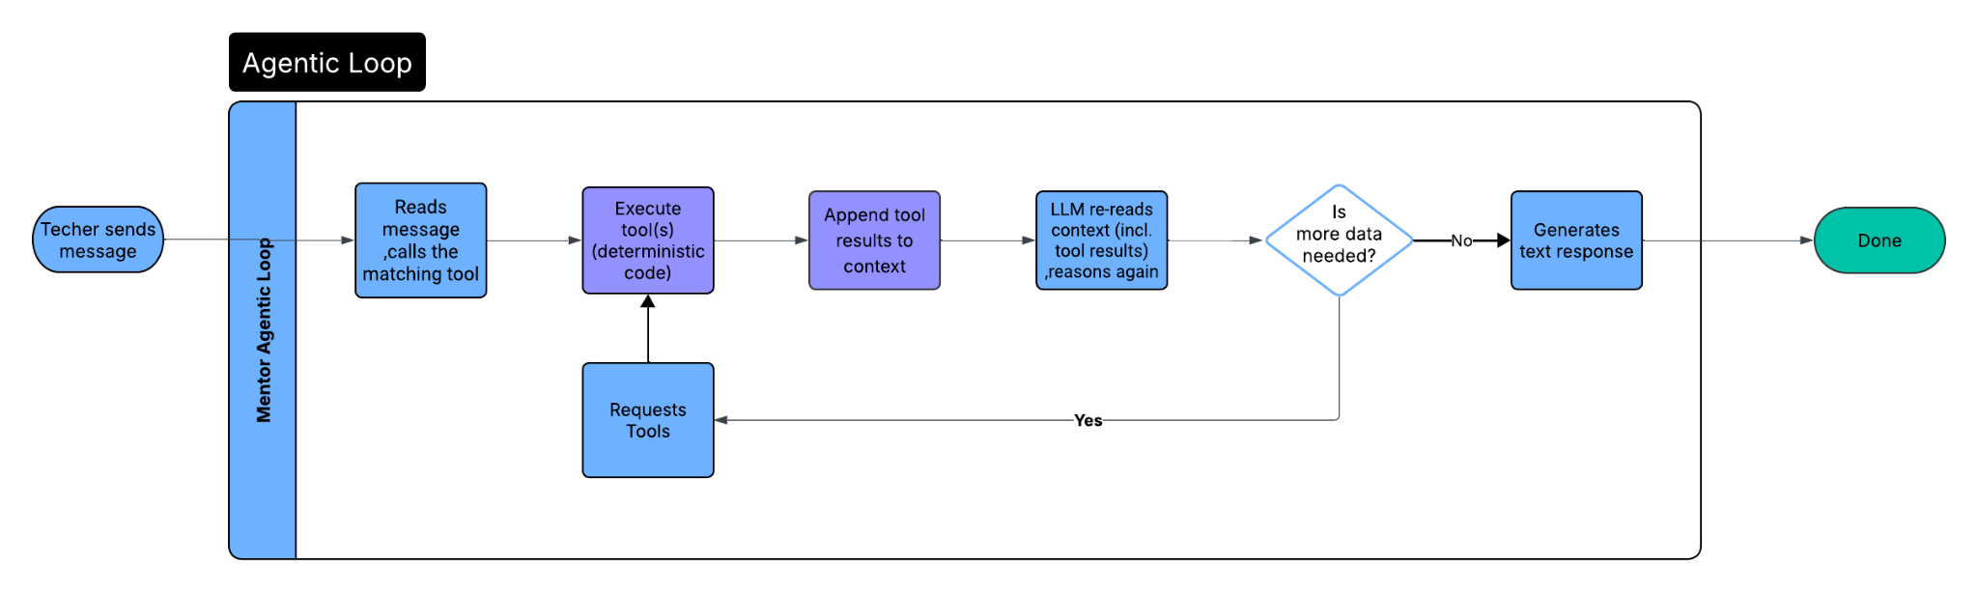
Figure 2 : The Mentor's Agentic Loop

4. Product

4.1 Key Project Requirements (Functional & Non-Functional)

ID | Type | Category | Requirement Description
1 | FR | Lesson Setup | The system shall allow a teacher to configure and start a lesson of up to 50 minutes, for a class of 5 to 30 students.
2 | FR | Lesson Setup | The teacher shall be able to set the class's grade level, subject topic, learning goals, and expected student misconceptions before the lesson starts.
3 | FR | Lesson Setup | The teacher shall be able to choose the behavioral mix of the virtual class from nine distinct student profiles (e.g. hyperactive, defiant, withdrawn, attentive).
4 | FR | Live Interaction | The teacher shall be able to speak to the class using their microphone, in Hebrew, and receive a spoken response from a student.
5 | FR | Live Interaction | The teacher shall be able to type a response instead of speaking, when speaking is not possible or not wanted.
6 | FR | Live Interaction | The teacher shall be able to address a specific named student and receive a response from that student in particular.
7 | FR | Live Interaction | The teacher shall be able to ask an open question to the whole class and have an appropriate student respond.
8 | FR | Live Interaction | The teacher shall be able to manage classroom behavior (e.g. reprimand a disruptive student) and see the student react in character.
9 | FR | Live Feedback | The teacher shall receive a live feedback card after each teaching move they make, scoring it on timing, tone, and pedagogy.
10 | FR | Live Feedback | The teacher shall be able to see written, short feedback in Hebrew explaining each score.
11 | FR | End-of-Lesson | At the end of a lesson, the teacher shall receive a written summary of their overall strengths and weaknesses across the whole lesson.
12 | FR | Post-Lesson Reflection | After a lesson, the teacher shall be able to chat with an AI mentor about their performance and ask follow-up questions.
13 | FR | Post-Lesson Reflection | The teacher shall be able to ask the mentor to compare two of their past lessons.
14 | FR | Post-Lesson Reflection | The teacher shall be able to ask the mentor how their performance has changed over time, and see the answer as a chart.
15 | FR | History | The teacher shall be able to view a list of their past lessons, each with its scores, feedback, and summary.
16 | FR | History | The teacher shall be able to reopen a specific past lesson's full record at any time.
17 | FR | Accessibility & Language | All content the teacher sees or hears shall be in Hebrew, displayed right-to-left, and use grammatically gender-correct phrasing.
18 | NFR | Real-Time Responsiveness | The system shall keep teacher-to-student-response latency low enough to feel like a live conversation, targeting well under 6 seconds end-to-end.
19 | NFR | Decision Transparency | Candidate selection and metric updates shall be deterministic and unit-testable, such that the same input always produces the same, inspectable output.
20 | NFR | Token & Cost Efficiency | LLM token usage per turn shall remain bounded and shall not scale linearly with class size.
21 | NFR | Pedagogical Validity | Evaluator scoring shall be grounded in an established pedagogical framework (Danielson Framework Components 2d and 3b), not arbitrary or unexplained criteria.
22 | NFR | Consistency of Evaluation | The same evaluation rubric shall be applied uniformly to every teacher and every lesson, so scores remain comparable across sessions.
23 | NFR | Age-Appropriate Output | Generated student speech shall remain reliably constrained to the configured grade level's vocabulary, tone, and behavior.
24 | NFR | Security & Least Exposure | Only the Gateway tier shall be reachable from the public internet; the database and the Simulation Core shall be reachable only from trusted internal components.
25 | NFR | Fail-Closed Reliability | A mid-lesson disconnect or persistence-layer outage shall not corrupt session state; the session shall terminate to an explicit "aborted" status rather than resume silently.
26 | NFR | Off-Hot-Path Scoring | Evaluation and summarization shall run asynchronously and shall never block or delay the student's live response.
27 | NFR | Extensibility | The persisted data model shall support new fields (guardrails, telemetry) as the system evolves, without requiring a formal schema migration.

4.2 System Architecture
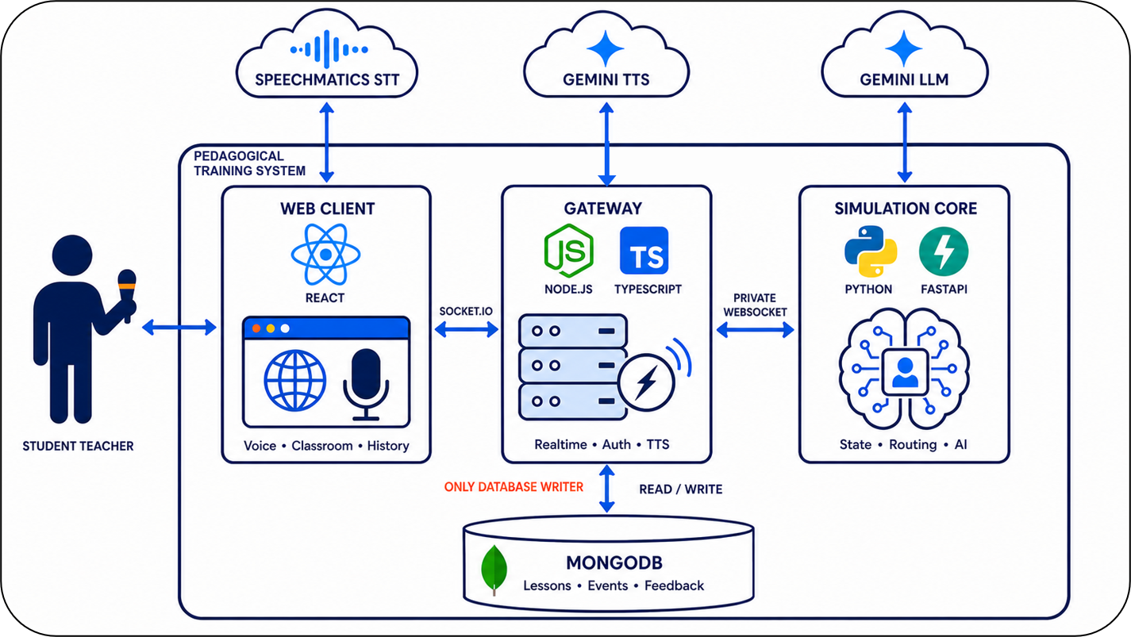
Figure 3 : Three tiers Architecture
4.2.1 The Three Layers and the Database
The system will use three application layers and MongoDB for persistent storage. The Web Client (React + TypeScript) will provide the illustrated classroom, microphone input, live coach card, lesson history, and Mentor interface. React will support the dynamic classroom UI, while TypeScript will keep the shared client–Gateway protocol type-safe. The client will communicate through the Gateway, except for its direct Speechmatics connection for speech-to-text. The Gateway (Node.js + TypeScript) will relay communication, act as the sole database writer, issue Speechmatics tokens, and stream TTS audio to the browser. Node.js suits these socket, streaming, and other I/O tasks. The Simulation Core (Python + FastAPI) will handle all deterministic simulation logic, including student states, routing, and candidate selection, alongside every Gemini LLM call. Python’s ecosystem and FastAPI’s asynchronous support suit this combination of rules and LLM orchestration. The Core will remain on a private network, accessible only through the Gateway. MongoDB will store lessons, events, feedback, and traces; its document model naturally accommodates their nested and variable structures.
Why split this way: This separation also allows each tier to be developed and tested independently through explicit interfaces.
Gemini LLM - Which Models, and Why - Hot-path roles (teacher-intent classifier, student Actors) will use a fast, cheap tier (Flash-Lite class) because they sit on the critical path to response time. Off-hot-path roles (Evaluator) will use a slightly heavier tier (Flash class) because Hebrew prose quality matters more there than shaving milliseconds. Every role will have a second Gemini model as fallback. A single provider (Gemini) will be used across all roles, to keep things simple - one quota surface, one caching mechanism, one set of known failure modes instead of two.
4.3 Use case Diagram 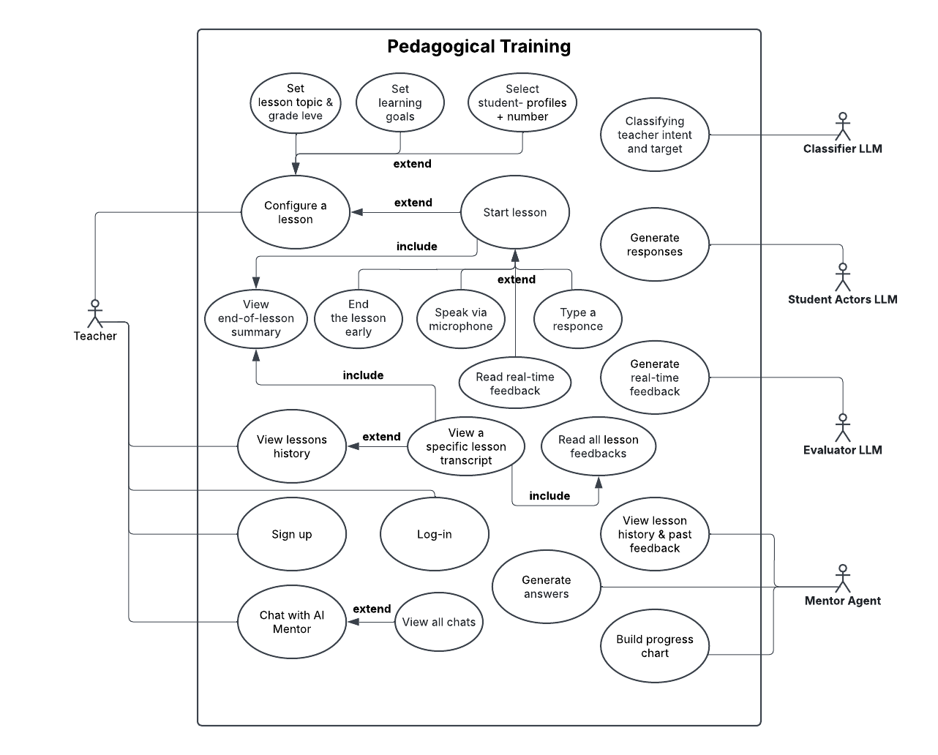

4.4 Activity Diagram - lesson flow
View of what happens across the lesson as a whole, from the moment the teacher starts the lesson to the moment the debrief summary appears, split across Teacher, System (deterministic code), and AI (LLM calls) lanes.
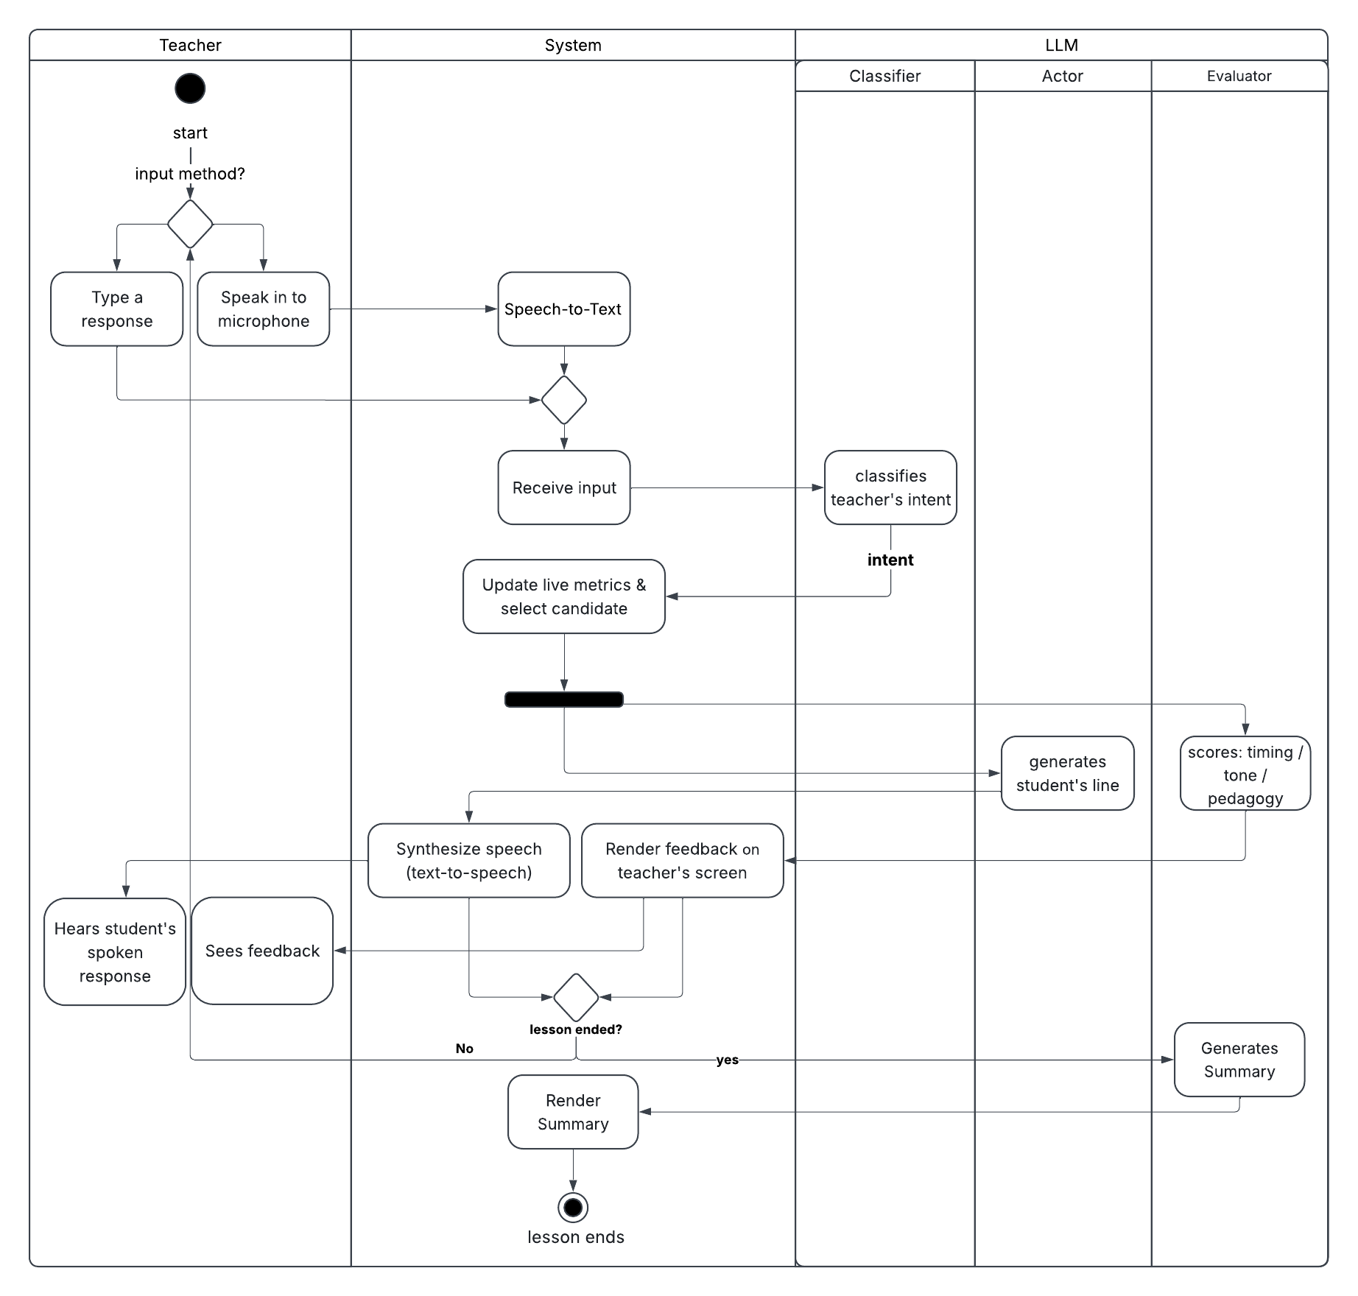

5. Challenges and Constraints
The architecture will address five main challenges:
- Latency: Selective Actor activation, evaluation outside the live response path, and bounded timeouts will reduce delays. However, external STT, LLM, and TTS services may still interrupt the natural pace of classroom interaction.
- Behavioral consistency and realism: Deterministic student states and selection rules will provide consistency, while persona and grade constraints will guide generated dialogue. Profile rules and numerical coefficients will still require expert calibration, and generated responses may vary in plausibility.
- Hebrew speech and turn boundaries: Semantic, acoustic, and manual endpointing, together with teacher-floor control, will help manage conversation turns. Recognition quality will still depend on room acoustics, microphones, accents, and speaking styles.
- Pedagogical trust: Feedback will be grounded in lesson goals and recorded interactions, but may still be inaccurate, biased, or overconfident. The Evaluator will assess wording and context, not vocal prosody. The system will therefore remain a formative practice aid with human oversight.

6. Expected Achievements
The expected outcome will be a complete, repeatable practice cycle: the teacher will configure a Hebrew classroom and lesson goals, conduct a voice-based simulation, review feedback and saved history, and reflect with the Mentor to identify an actionable next step. The project will aim to provide believable student interactions, evidence-grounded guidance, and a maintainable foundation for further development. Phase A establishes the design and technical feasibility; Phase B will evaluate reliability, usability, classroom realism, and the usefulness of the feedback.
7. Verification and KPIs
Verification will combine automated logic and contract tests with full-browser, real-microphone trials and human review. The sample sizes and numerical thresholds below are proposed project acceptance targets for Phase B.

Test area | Method | Expected result / acceptance target
Lesson setup and lifecycle | Enter valid and invalid grade, topic, goals, duration, class size and distribution; start, stop and reopen the session. | Invalid input is blocked; the configured class opens; the completed lesson appears in the correct user's history.
State and speaker selection | Use fixed seeds to test profile-specific state changes, eligibility, exclusions, cooldowns, candidate selection and arbitration. | The expected pupil is selected for a fitting action; ineligible pupils are excluded; bounded background rules hold.
Hebrew voice turn | Speak a complete Hebrew teacher turn through a real microphone and follow it through STT, Gateway, Core, Actor and TTS. | One final teacher turn is accepted; the chosen pupil becomes visible and audible; the trace records each stage.
Teacher interruption | Begin speaking while pupil audio is playing. | The teacher reclaims the floor; the pupil audio is reduced or stopped; stale output does not resume or enter memory as fully heard.
Evaluator, summary and Mentor | Run a known lesson with an assessable move and a noise/unfinished fragment; finish, leave the page, reopen history and question the Mentor. | Only the real move is scored; summary state moves from pending to a truthful terminal result; Mentor claims come from the correct stored lesson.
Failure handling and user-data isolation | Try invalid authentication, a second user, missing TTS audio, Core disconnect and unavailable persistence. | Cross-user access is blocked; failures are visible; no false speech bubble or false completion is produced.
Response time and audio delivery | Measure at least 100 real-microphone turns that should trigger a spoken response, from end-of-speech to first audible student audio. Record missing audio as a failure and intentional interruptions separately. | Median latency ≤ 3 seconds; at least 95% of expected responses are audible within 6 seconds.
Lesson endurance | Run a separate 50-minute lesson with continued teacher interaction. | The session remains usable and finishes with a stored summary.
usability targets | Observe 12 pre-service teachers completing the core prepare-teach-review-reflect workflow; record assistance and administer the System Usability Scale (SUS). | At least 11/12 complete the workflow without help, and the overall SUS score is >= 86.
pedagogical review | Three independent pedagogical reviewers score 60 feedback or summary outputs on a five-point rubric and flag critical failures. | At least 80% outputs receive 4 or 5 out of 5 from all three reviewers, with zero unresolved critical failures. A critical failure is harmful advice, an invented lesson event or a confident unsupported conclusion.

8. AI Tools and Prompts
AI tools were used as supporting tools during the Phase A investigation. They helped refine literature-search queries, map assignment requirements, compare engineering alternatives, review consistency between the book and the system architecture, and improve the clarity of the academic English. We selected the final content and decisions.
Tool | Direct link | Use in the Phase A investigation
OpenAi | ChatGPT | Requirements mapping, comparison of architecture alternatives, consistency review and academic-English editing.
Google Gemini | Gemini | Refining literature-search queries, organizing themes across source summaries and providing a second perspective on terminology and clarity.
Representative prompt - research. "Suggest search terms for peer-reviewed studies on virtual-classroom simulations in pre-service teacher education. Group the terms by pedagogical outcomes, classroom management and LLM-based agents."
Representative prompt - requirements. "Compare the attached Phase A instructions with the document outline. List each required item, where it appears, and any item that is not yet covered. Do not invent missing requirements."
Representative prompt - engineering alternatives. "Compare the following architecture alternatives in terms of latency, cost, explainability, scalability and failure isolation. Separate verified project facts from assumptions."
Representative prompt - review and editing. "Review the following paragraph for unclear terminology, internal contradictions and unsupported claims.”

9. References
1. Asadi, C., & Naem, A+B. (2026). Pedagogical Training: Capstone Project Phase A (Project Code: 25-2-D-17). Software Engineering Department, Ort Braude Academic College of Engineering. הדרכה פדגוגית שלב א , הדרכה פדגוגית שלב ב
2. Asregid, D. (2026). Practicum supervisors’ structured feedback and pre-service teachers’ engagement in reflective practice. Reflective Practice, 27(4), 521–531.
https://www.researchgate.net/publication/398876600_Practicum_supervisors'_structured_feedback_and_pre-service_teachers'_engagement_in_reflective_practice
3. Buitrago López, A., Pastor-Galindo, J., & Ruipérez-Valiente, J. A. (2026). Should LLM Agents Decide in Social Simulations? Comparing Finite-State and LLM-Based Decision Policies. arXiv preprint arXiv:2606.12369.https://arxiv.org/html/2606.12369v1
4. Cohen-Azaria, Y. (2021). Perceptions and experiences of homeroom teachers regarding disciplinary issues in elementary schools. Shaanan Academic Religious College of Education. https://www.shaanan.ac.il/wp-content/uploads/2021/06/עזריה-כהן.pdf
5. Danielson, C. (2013). The Framework for Teaching Evaluation Instrument. New York State Education Department. https://www.nysed.gov/sites/default/files/danielson-teacher-rubric-2013-instructionally-focused.pdf#page=21
6. Dicke, T., Parker, P. D., Holzberger, D., Kunina-Habenicht, O., Kunter, M., & Leutner, D. (2015). Beginning teachers' efficacy and emotional exhaustion: Latent changes, reciprocity, and the influence of professional knowledge. Contemporary Educational Psychology, 41, 62-72. https://doi.org/10.1016/j.cedpsych.2014.11.003
7. Ersozlu, Z., Ledger, S., Ersozlu, A., Mayne, F., & Wildy, H. (2021). Mixed-reality learning environments in teacher education: An analysis of TeachLivE research. SAGE Open, 11(3), 1-10. https://doi.org/10.1177/21582440211032155
8. Gourneau, B. (2014). Challenges in the first year of teaching: Lessons learned in an elementary education resident teacher program. Contemporary Issues in Education Research, 7(4), 299-316. https://files.eric.ed.gov/fulltext/EJ1073282.pdf
9. Ingersoll, R. M. (2003). Is there really a teacher shortage? Center for the Study of Teaching and Policy, University of Washington. https://repository.upenn.edu/gse_pubs/133
10. Lee, U., Lee, S., Koh, J., Jeong, Y., Jung, H., Byun, G., Lee, Y., Moon, J., Lim, J., & Kim, H. (2023). Generative agent for teacher raining: Designing educational problem-solving simulations with large language model-based agents for pre-service teachers. Retrieved from https://www.semanticscholar.org/paper/Generative-Agent-for-Teacher-Training
11. SimSchool. (n.d.). The classroom simulator for educators. Retrieved May 2026, from https://www.simschool.org/home/simschool/
12. Yilmaz, O., & Hebebci, M. T. (2022). The use of virtual environments and simulation in teacher training. International Journal on Social and Education Sciences, 4(3), 446-457. https://files.eric.ed.gov/fulltext/EJ1347603.pdf
13. Zhang, Z., Zhang-Li, D., Yu, J., Gong, L., Zhou, J., Hao, Z., Jiang, J., Cao, J., Liu, H., Liu, Z., Hou, L., & Li, J. (2024). Simulating Classroom Education with LLM-Empowered Agents. arXiv preprint arXiv:2406.19226. https://arxiv.org/abs/2406.19226
10. Appendices
1. Assistant Principal, Leo Baeck Elementary School, Haifa. Personal interview with Dganit Vainer and Harel Aronovich. (August 23, 2026). – interview link
2. Pedagogical Validation Survey Results – Result link
3. Prototype screenshots – Screenshots link

